WEEK 2 – Entity Framework Core 8.0 Guided Hands-On Exercises
Submitted By: Nishant Kumar
Superset ID: 7985565
College: C. V. Raman Global University, Odisha
Registration No.: 2301020208
Email: nishantkumar6205003458@gmail.com

Lab 1: Understanding ORM with a Retail Inventory System Scenario:
You’re building an inventory management system for a retail store. The store wants to track products, categories, and stock levels in a SQL Server database.
Objective: Understand what ORM is and how EF Core helps bridge the gap between C# objects and relational tables.
Steps:
1. What is ORM?
• Explain how ORM maps C# classes to database tables.
• Benefits: Productivity, maintainability, and abstraction from SQL.
2. EF Core vs EF Framework:
• EF Core is cross-platform, lightweight, and supports modern features like LINQ, async queries, and compiled queries.
• EF Framework (EF6) is Windows-only and more mature but less flexible.
3. EF Core 8.0 Features: • JSON column mapping.
• Improved performance with compiled models.
• Interceptors and better bulk operations.
4. Create a .NET Console App: dotnet new console -n RetailInventory cd RetailInventory
5. Install EF Core Packages: dotnet add package Microsoft.EntityFrameworkCore.SqlServer dotnet add package Microsoft.EntityFrameworkCore.Design

Install EF Core Packages
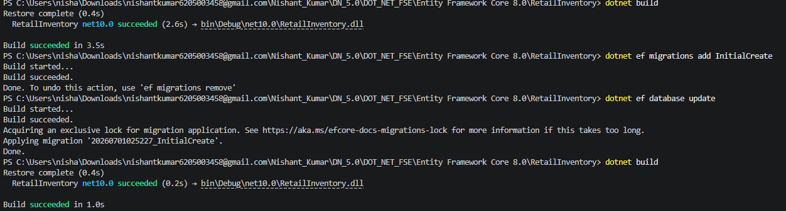

Lab 2: Setting Up the Database Context for a Retail Store
Question
Scenario:
The retail store wants to store product and category data in SQL Server.
Objective:
Configure DbContext and connect to SQL Server.
Steps:
1. Create Models:
public class Category {
public int Id { get; set; }
public string Name { get; set; }
public List Products { get; set; }
}
public class Product {
public int Id { get; set; }
public string Name { get; set; }
public decimal Price { get; set; }
public int CategoryId { get; set; }
public Category Category { get; set; }
}
2. Create AppDbContext:
public class AppDbContext : DbContext {
public DbSet Products { get; set; }
public DbSet Categories { get; set; }
protected override void OnConfiguring(DbContextOptionsBuilder optionsBuilder) {
optionsBuilder.UseSqlServer("Your_Connection_String_Here");
}
}
3. Add Connection String in appsettings.json (optional for ASP.NET Core).

Category.cs

using System.Collections.Generic;

namespace RetailInventory.Models
{
public class Category
{
public int Id { get; set; }

public string Name { get; set; } = string.Empty;

public List<Product> Products { get; set; } = new List<Product>();
}
}

Product.cs

namespace RetailInventory.Models
{
public class Product
{
public int Id { get; set; }

public string Name { get; set; } = string.Empty;

public decimal Price { get; set; }

public int CategoryId { get; set; }

public Category? Category { get; set; }
}
}

AppDbContext.cs

using Microsoft.EntityFrameworkCore;
using RetailInventory.Models;

namespace RetailInventory.Data
{
public class AppDbContext : DbContext
{
public DbSet<Product> Products { get; set; }

public DbSet<Category> Categories { get; set; }

protected override void OnConfiguring(DbContextOptionsBuilder optionsBuilder)
{
optionsBuilder.UseSqlServer(
@"Server=.\SQLEXPRESS;Database=RetailInventoryDB;Trusted_Connection=True;TrustServerCertificate=True");
}
}
}

Project Structure
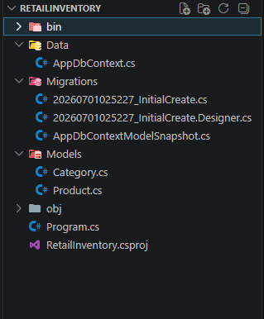
Output Screenshot
Build Command
dotnet build



Lab 3: Using EF Core CLI to Create and Apply Migrations
Question
Scenario:
The retail store's database needs to be created based on the models you've defined. You’ll use EF Core CLI to generate and apply migrations.
Objective:
Learn how to use EF Core CLI to manage database schema changes.
Steps:
1. Install EF Core CLI (if not already):
dotnet tool install --global dotnet-ef
2. Create Initial Migration:
dotnet ef migrations add InitialCreate
This generates a Migrations folder with code that represents the schema.
3. Apply Migration to Create Database:
dotnet ef database update
4. Verify in SQL Server:
Open SQL Server Management Studio (SSMS) or Azure Data Studio and confirm that tables Products and Categories are created.

Commands Used
- dotnet tool install --global dotnet-ef
- dotnet ef migrations add InitialCreate
- dotnet ef database update
SSMS Screenshot
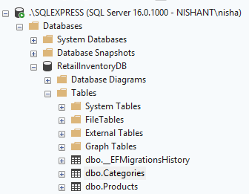
Output Screenshot

Lab 4: Inserting Initial Data into the Database
Question
Scenario:
The store manager wants to add initial product categories and products to the system.
Objective:
Use EF Core to insert records using AddAsync and SaveChangesAsync.
Steps:
1. Insert Data in Program.cs:
using var context = new AppDbContext();
var electronics = new Category { Name = "Electronics" };
var groceries = new Category { Name = "Groceries" };
await context.Categories.AddRangeAsync(electronics, groceries);
var product1 = new Product
{
Name = "Laptop",
Price = 75000,
Category = electronics
};
var product2 = new Product
{
Name = "Rice Bag",
Price = 1200,
Category = groceries
};
await context.Products.AddRangeAsync(product1, product2);
await context.SaveChangesAsync();
2. Run the App:
dotnet run
3. Verify in SQL Server:
Check that the data is inserted correctly.

using RetailInventory.Data;
using RetailInventory.Models;
using Microsoft.EntityFrameworkCore;

using var context = new AppDbContext();

// Create Categories
var electronics = new Category { Name = "Electronics" };
var groceries = new Category { Name = "Groceries" };

await context.Categories.AddRangeAsync(electronics, groceries);

// Create Products
var product1 = new Product
{
Name = "Laptop",
Price = 75000,
Category = electronics
};

var product2 = new Product
{
Name = "Rice Bag",
Price = 1200,
Category = groceries
};

await context.Products.AddRangeAsync(product1, product2);

await context.SaveChangesAsync();

Console.WriteLine("Data Inserted Successfully!");

SSMS Screenshot:

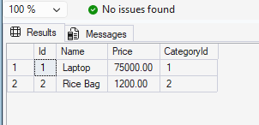

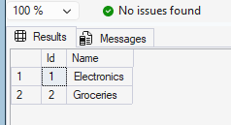

Lab 5: Retrieving Data from the Database
Question
Scenario:
The store wants to display product details on the dashboard.
Objective:
Use Find, FirstOrDefault, and ToListAsync to retrieve data.
Steps:
1. Retrieve All Products:
var products = await context.Products.ToListAsync();
foreach (var p in products)
Console.WriteLine($"{p.Name} - ₹{p.Price}");
2. Find by ID:
var product = await context.Products.FindAsync(1);
Console.WriteLine($"Found: {product?.Name}");
3. FirstOrDefault with Condition:
var expensive = await context.Products.FirstOrDefaultAsync(p => p.Price > 50000);
Console.WriteLine($"Expensive: {expensive?.Name}");

using Microsoft.EntityFrameworkCore;
using RetailInventory.Data;

using var context = new AppDbContext();

Console.WriteLine("===== All Products =====");

var products = await context.Products.ToListAsync();

foreach (var p in products)
{
Console.WriteLine($"{p.Name} - ₹{p.Price}");
}

Console.WriteLine();

var product = await context.Products.FindAsync(1);

Console.WriteLine($"Found : {product?.Name}");

Console.WriteLine();

var expensive = await context.Products
.FirstOrDefaultAsync(p => p.Price > 50000);

Console.WriteLine($"Expensive Product : {expensive?.Name}");

Output:

